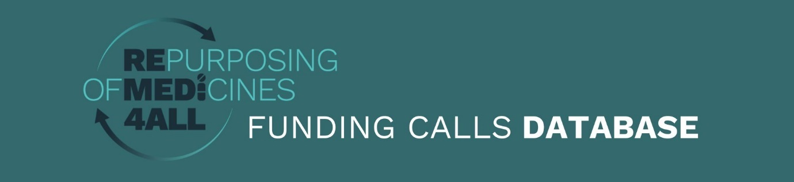

New Funding Call Form
Please complete all fields where applicable.
Name: Name of the funding call
Description: Text description of the call (enter detailed text description, max 300 words)
URL: Website for the call.
Funder(s): List of funders included in the call
Deadline Model: Single or double stage?
Type of funding: Non-dilutive (grant, donation etc) or Dilutive funding (equity share)?
Call Open Date: Date that the call formally opens (DD/MM/YYYY)
Deadline First stage (LoI/pre-proposal): Deadline for the letter of interest or application for single stage (DD/MM/YYYY)
Announcement of Applicants selected for stage 2: Announcement date for applicants selected to go through to second stage application (DD/MM/YYYY)
Deadline Second stage (Full Application): Deadline for the full application for those selected to complete a full application (DD/MM/YYYY)
Grant Decision Date: Announcement date of the grant decision (DD/MM/YYYY)
Full Grant Amount: Amount included in the grant for all projects. Enter currency unit and amount – eg. £50000 or €100K
Maximum amount of funding per project: The maximum amount for one project selected by the call. Enter currency unit and amount – eg. £50000 or €100K
Maximum duration of project (years): Maximum duration of a selected project. Enter in multiples of years. For example for 3 years enter 3, for 18 months enter 1.5.
Type of projects included: Select one or more from…
- Drug candidate identification (in silico and other)
- In vitro/in vivo candidate validation
- Clinical trial (early phase – dose, toxicity etc)
- Clinical trial (efficacy – Phase 2)
- Clinical trial (efficacy - Phase 2/3)
- Clinical trial (efficacy – Phase 3)
- Clinical trial – registration
- Clinical trial - any phase
- Other biological study
- Proof of concept
- Pilot study
- Therapy optimisation study
- Other data generation study (e.g. retrospective analysis, case series etc)
- Other
- All

Type of applicants allowed: Select one or more from:
- Unrestricted
- Academic
- Clinical
- Collaborative group
- SME/Company
- Patient organisation
- Other
Geographical Scope: Select from:
- EU
- Europe, including non-EU
- Single country
- Listed countries
- Unrestricted
Country/Countries: Enter the list of specific countries if geographical scope is single country or listed countries
Disease Area: Enter list of disease areas included in the call.
Language: Enter primary language of the call text.

Call email: Email address for potential applications and questions

