This toolkit aims to equip REMEDi4ALL partners with social media resources to promote the upcoming iDR25 Conference that is taking place on 7th - 8th May 2025.

In this global event, key opinion leaders from both the research and patient communities, funders, regulators and representatives from the private sector will participate to collectively advance innovative drug repurposing in Europe and beyond.

If you would like to promote the conference through your communication channels, such as social media, email lists, websites, and newsletters, you can help us reach a wider audience and attract more participants. The more people hear about this conference, the more impact we can make in advancing the drug repurposing landscape. To make it easy for you to promote the conference, you can use the below materials.

INSTRUCTIONS:
- Feel free to copy and paste the text for your social media platforms/newsletters, and/or customise it to speak to your audiences.
- You can download the visual assets using this link to ensure high-resolution images. Please avoid copying and pasting the preview images from this document.




EVENT SUMMARY:
- Title: iDR25 –Medicines Reimagined
- Event theme: Unlocking the potential of existing drugs for patient benefit
- Date: 7th – 8th May 2025
- Location: Felix Meritis, Keizersgracht 324, 1016 EZ Amsterdam, The Netherlands
- Registration link: https://www.eventbrite.co.uk/e/idr25-medicines-reimagined-tickets-1010504755927

NEWSLETTER/EVENT PAGE BLURB
Medicines Reimaged, the International Drug Repurposing Conference 2025 (#iDR25) hosted by REMEDi4ALL and Beacon aims to unlock the full potential of medicines by driving innovation for patient benefit. This global event will explore how cutting-edge artificial intelligence (AI) approaches are transforming drug discovery, alongside innovative business models and regulatory pathways for market access. You’ll engage with key opinion leaders across research and patient communities, policymakers, funders, regulators and the private sector.
Discover how funders are shaping the future of drug repurposing and explore real-life examples. Together with others who are passionate about the transformative potential of medicines, this is your chance to connect, innovate and reshape drug repurposing.

The agenda features thought-provoking plenaries, expert discussions and sessions on AI in clinical decision-making, new opportunities in drug repurposing, and addressing the needs of underserved populations - including rare diseases, rare cancers, and paediatric and rare infectious conditions. We'll also dive into innovative trial designs, policy, and pathways to improve patient access.

Explore cutting-edge insights, discuss challenges, and engage with leading experts. Find out more about the speakers, location, ticket prices and more here.

SOCIAL MEDIA CAMPAIGN CONTENT AND VISUALS

Suggested date | Copy | Visuals
8th October 2024 | LINKEDIN & FACEBOOK:  ⏰#iDR25 Early Bird tickets are now available! Join key opinion leaders from research, patient communities, funders, regulators, and the private sector to unlock the potential of drug repurposing for patient benefits. This year’s event is set in the stunning city of Amsterdam!  🎟️ Secure your spot and get your discounted Early Bird tickets here: Join iDR25, the international drug repurposing conference (remedi4all.org)  #EarlyBird #iDR25 #REMEDi4ALL #Beacon #DrugRepurposing #PatientCare #PatientBenefit #GlobalConference #ExistingDrugs  X:  #iDR25 Early Bird tickets are now available! Join key opinion leaders to unlock the potential of drug repurposing for patient benefits.  👉 Get your discounted ticket here: Join iDR25, the international drug repurposing conference (remedi4all.org) | 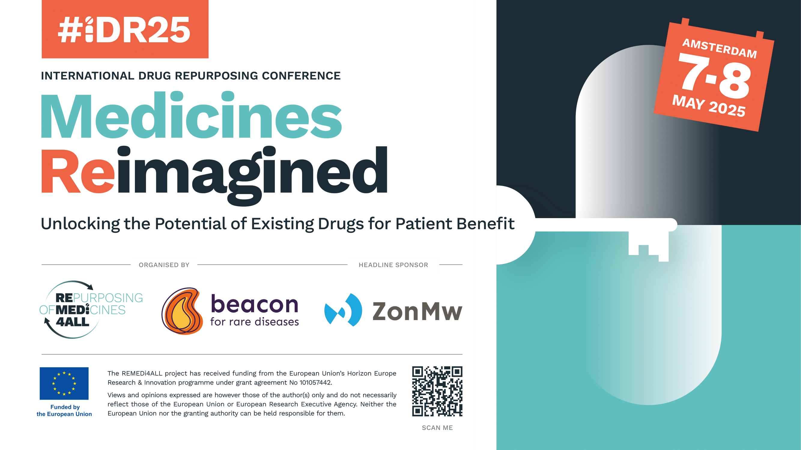
12th November 2024 | LINKEDIN & FACEBOOK:  Get ready for #iDR25, where you can:  ✨Discover innovative drug repurposing approaches  🤝Engage with leading experts  💡Pave the way for patient-driven research  💬Discuss the current drug repurposing landscape  🌐Become part of a thriving community  Book your discounted Early Bird tickets here: Join iDR25, the international drug repurposing conference (remedi4all.org)  #DrugRepurposing #REMEDi4ALL #Beacon #Innovation #PatientCare #PatientBenefit #EarlyBird  X:  Get ready for #iDR25, to:  🌟 Discover innovative drug repurposing approaches  🤝Engage with leading experts  💡 Pave the way for patient-driven research  🌐 Become part of a thriving community  👉 Book your place here: Join iDR25, the international drug repurposing conference (remedi4all.org) | 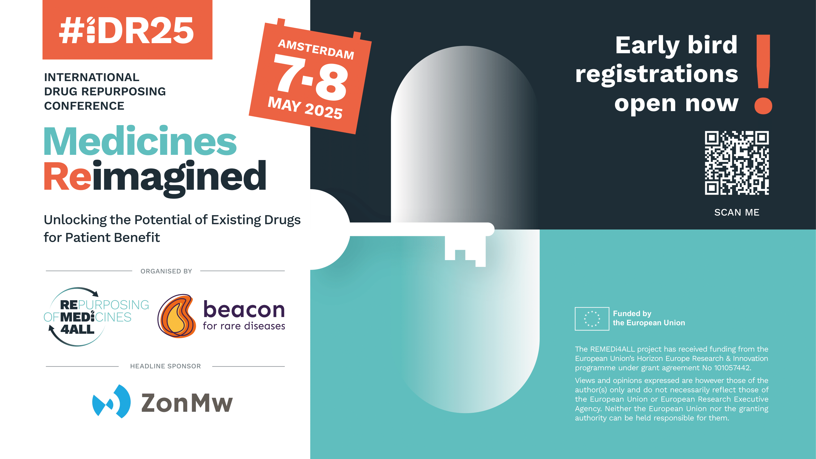
10 December 2024 | LINKEDIN & FACEBOOK:  🚀 Excited to announce that #iDR25 is offering an incredible opportunity to dive into 3 unique paths of knowledge and innovation!  🌟 Whether you're passionate about AI, patient care, or innovative trial designs, this event is packed with expert speakers, plenaries, and discussions to spark new insights and connections.  Here’s what to look forward to:  👉AI in clinical decision-making and discovering new drug repurposing opportunities  👉 Addressing underserved populations with drug repurposing for rare diseases, rare cancers, children, and rare infectious conditions  👉 Exploring innovative trial designs and repurposing policies to enhance patient access  Click to learn more about the programme: Join iDR25, the international drug repurposing conference (remedi4all.org)  Register here: https://www.eventbrite.co.uk/e/idr25-medicines-reimagined-tickets-1010504755927  #iDR25 #REMEDi4ALL #Beacon #DrugRepurposing #PatientCare #PatientBenefit  X:  🌟 Whether you're passionate about AI, patient care, or innovative trial designs, iDR25 is packed with expert speakers, plenaries, and discussions.  👉 Find out more here: Join iDR25, the international drug repurposing conference (remedi4all.org) | 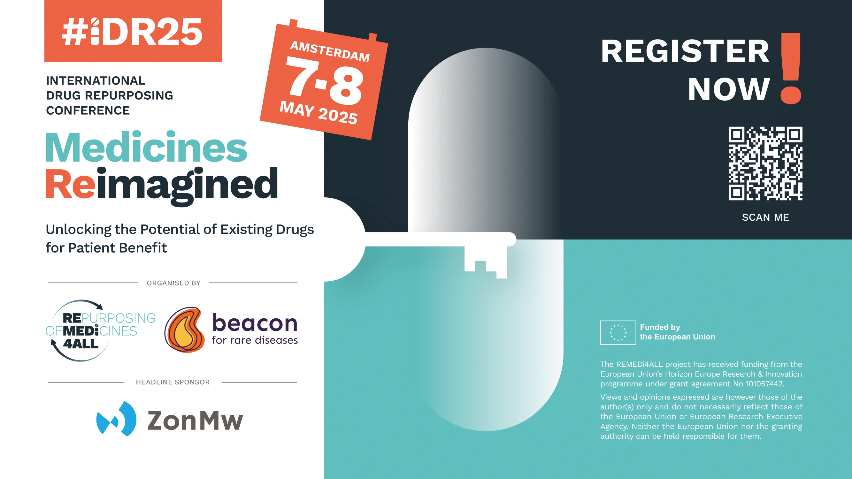
28th January 2025 | LINKEDIN & FACEBOOK:  🌐Ready to expand your network and connect with like-minded professionals in the world of drug repurposing? #iDR25 is your perfect opportunity!  🤝Join to share knowledge, experiences, and best practices while fostering collaboration and building lasting relationships. It's the ideal space to widen your professional network and create new bonds that drive innovation.  Register here: https://www.eventbrite.co.uk/e/idr25-medicines-reimagined-tickets-1010504755927  Click here to find out more about iDR25: Join iDR25, the international drug repurposing conference (remedi4all.org)  #iDR25 #REMEDi4ALL #Beacon #DrugRepurposing  X:  🌐Ready to expand your network and connect with like-minded professionals in the world of drug repurposing? #iDR25 is your perfect opportunity!  👉Click here to register: Join iDR25, the international drug repurposing conference (remedi4all.org)
25th February 2025 | LINKEDIN & FACEBOOK:  🌟 Join #iDR25 and connect with Leading Experts in the Drug Repurposing Landscape! This is your chance to explore unparalleled opportunities to learn, network, and actively contribute to a community focused on redefining the potential of medicines.  Connect with:  👥 Patient Organisations  🔬 Researchers  🏭 Industry Professionals  💸 Funders  🏛️ Policy Makers  … and many more.  Click here to register: Join iDR25, the international drug repurposing conference (remedi4all.org)  #iDR25 #REMEDi4ALL #Beacon #DrugRepurposing  X:  Join #iDR25 to connect with leading experts in drug Repurposing! Engage with:  👥 Patient Organisations  🔬 Researchers  🏭 Industry Professionals  💸 Funders  🏛️ Policy Makers  … & more.  👉Register here: Join iDR25, the international drug repurposing conference (remedi4all.org)
25th March 2025 | LINKEDIN & FACEBOOK:  As an EU-funded initiative, REMEDi4ALL is pushing the boundaries of drug repurposing in Europe. By focusing on already approved, discontinued, or investigational therapeutics, the platform aims to reduce the time and cost of drug development.  Don’t miss the chance to be part of this journey! Join #iDR15 - the International Drug Repurposing Conference - co-organised by REMEDi4ALL & Beacon and discover how we can unlock the potential of existing medicines to improve patient outcomes.  👉 More info: Join iDR25, the international drug repurposing conference (remedi4all.org)  📝 Register here: https://www.eventbrite.co.uk/e/idr25-medicines-reimagined-tickets-1010504755927  #DrugRepurposing #iDR25 #REMEDi4ALL #Beacon  X:  Don’t miss your chance to be part of #iDR15 - the International Drug Repurposing Conference - to discover how we can unlock the potential of existing medicines to improve patient outcomes.  👉 Register here: Join iDR25, the international drug repurposing conference (remedi4all.org)
29th April 2025 | LINKEDIN & FACEBOOK:  🎉 Only 8 days to go until #iDR25 - the International Drug Repurposing Conference! Get ready to join us in Amsterdam for an exciting opportunity to learn, share & advance the field of drug repurposing.  👉 More info here: Join iDR25, the international drug repurposing conference (remedi4all.org)  👉Secure one of the last available spots here: https://www.eventbrite.co.uk/e/idr25-medicines-reimagined-tickets-1010504755927  X:  🎉 Only 8 days to go until #iDR25 in Amsterdam! Get ready for an exciting opportunity to learn, share & advance the field of drug repurposing.  👉More info & book your place here: Join iDR25, the international drug repurposing conference (remedi4all.org)

